Virtual Data Analyst Internship
Week 4 Final Report
Comprehensive Data Analysis, Statistical Modeling and Reporting using R
Sample Dataset: Titanic Dataset (Public Dataset)

1. Introduction
This final report presents a comprehensive data analysis of the Titanic dataset using R. The project covers data preparation, exploratory visualization, statistical analysis, hypothesis testing, predictive modeling, model evaluation, and diagnostic analysis. The objective is to demonstrate how a data-driven workflow can transform a structured dataset into interpretable findings and predictive insights.
The analysis focuses on passenger survival as the primary outcome. Numerical and categorical variables are examined through descriptive statistics and visualizations, statistical testing is used to assess important relationships, and logistic regression is used to predict survival. Model performance is evaluated through a train-test split, five-fold cross-validation, classification metrics, ROC/AUC analysis, and diagnostic assessment.

2. Project Objectives
- Prepare and validate the Titanic dataset for analysis.
- Explore passenger characteristics and survival patterns using appropriate visualizations.
- Apply descriptive and inferential statistical techniques.
- Test the association between passenger class and survival.
- Develop a logistic regression classification model for survival prediction.
- Evaluate predictive performance using train-test evaluation and five-fold cross-validation.
- Use ROC/AUC analysis and diagnostic techniques to assess model quality.
- Communicate findings, limitations, practical implications, and future improvements clearly.

3. Dataset Overview
The Titanic dataset contains 891 passenger records and information describing passenger identity, survival outcome, passenger class, demographic characteristics, family-related variables, fare, and embarkation.
Attribute | Details
Dataset | Titanic
Records | 891
Target variable | Survived
Original variables | PassengerId, Survived, Pclass, Name, Sex, Age, SibSp, Parch, Ticket, Fare, Cabin, Embarked
Prediction type | Binary classification
Main modeling predictors | Pclass, Sex, Age, Fare
The dataset is suitable for comprehensive analysis because it contains categorical and numerical variables and a binary survival outcome that supports classification modeling.

4. Data Preparation and Cleaning
The dataset was inspected using structure, summary statistics, and missing-value checks. Missing Age values were replaced using the median Age, while missing Embarked values were handled using the most frequent category. Variables required for statistical testing and classification were converted to appropriate factor types.
data$Age[is.na(data$Age)] <- median(data$Age, na.rm = TRUE)
data$Embarked[data$Embarked == ""] <- NA
modeEmbarked <- names(sort(table(data$Embarked), decreasing = TRUE))[1]
data$Embarked[is.na(data$Embarked)] <- modeEmbarked
data$Survived <- as.factor(data$Survived)
data$Pclass <- as.factor(data$Pclass)
data$Sex <- as.factor(data$Sex)
data$Embarked <- as.factor(data$Embarked)

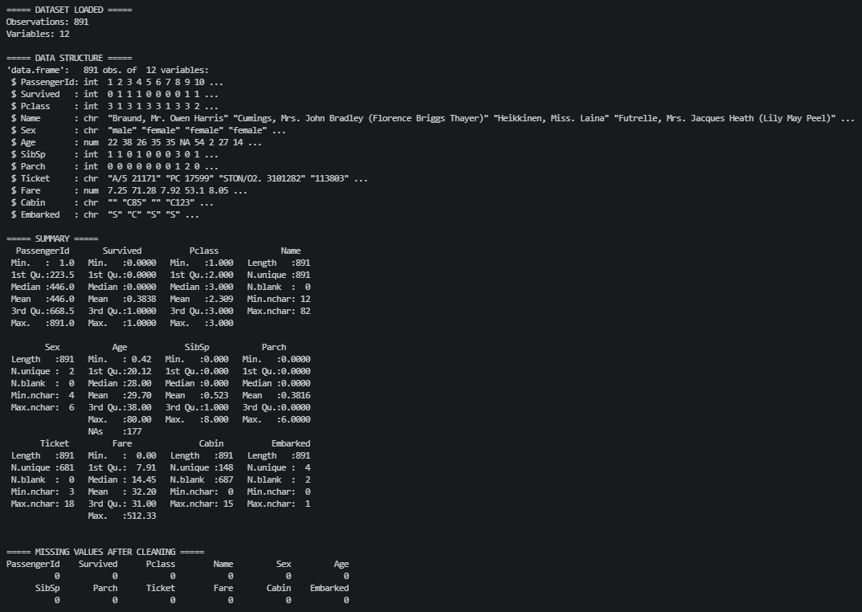
4.1 Data Preparation and Cleaning Output:

5. Exploratory Data Analysis and Visualization
Visual analysis was used to examine survival patterns, passenger age distribution, and relationships between numerical variables. Different chart types were selected according to the variables and analytical question.

5.1 Survival by Passenger Class
A grouped bar chart was used to compare surviving and non-surviving passengers across the three passenger classes. The visualization shows noticeable differences in survival outcomes between passenger classes.
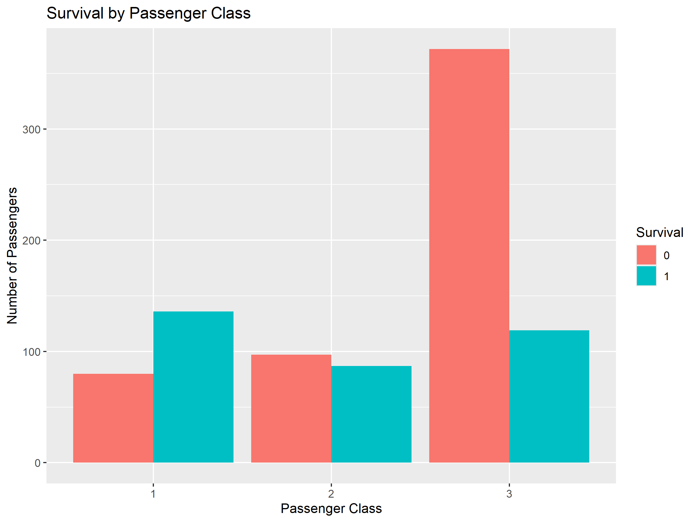
ggplot(data, aes(x = factor(Pclass), fill = factor(Survived))) +
geom_bar(position = "dodge") +
labs(title = "Survival by Passenger Class",
x = "Passenger Class",
y = "Number of Passengers",
fill = "Survival")

5.2 Distribution of Passenger Age
A histogram was used to examine the distribution of passenger ages and provides an overview of the concentration and spread of ages in the dataset.
ggplot(data, aes(x = Age)) +
geom_histogram(bins = 30) +
labs(title = "Distribution of Passenger Age",
x = "Age",
y = "Frequency")

5.2.1 Distribution of Passenger Age Output:
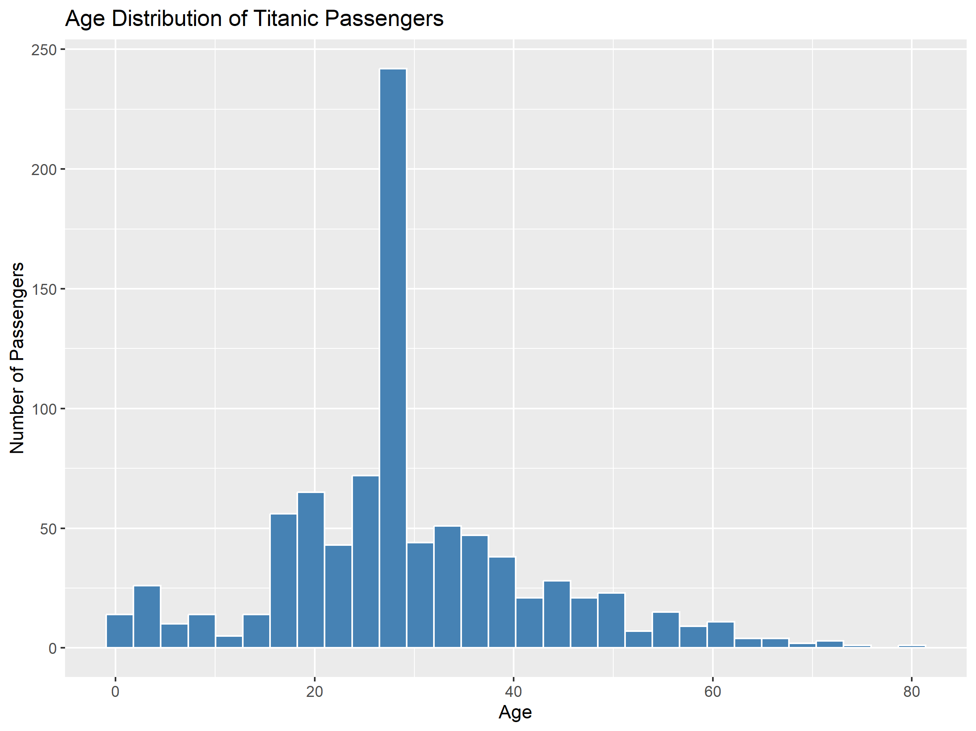

5.3 Relationship Between Age and Fare
A scatter plot was used to examine the relationship between passenger age and fare. The visualization shows substantial variation in fare values and does not indicate a simple strong linear pattern.
ggplot(data, aes(x = Age, y = Fare)) +
geom_point(alpha = 0.5) +
labs(title = "Relationship Between Age and Fare",
x = "Age",
y = "Fare")
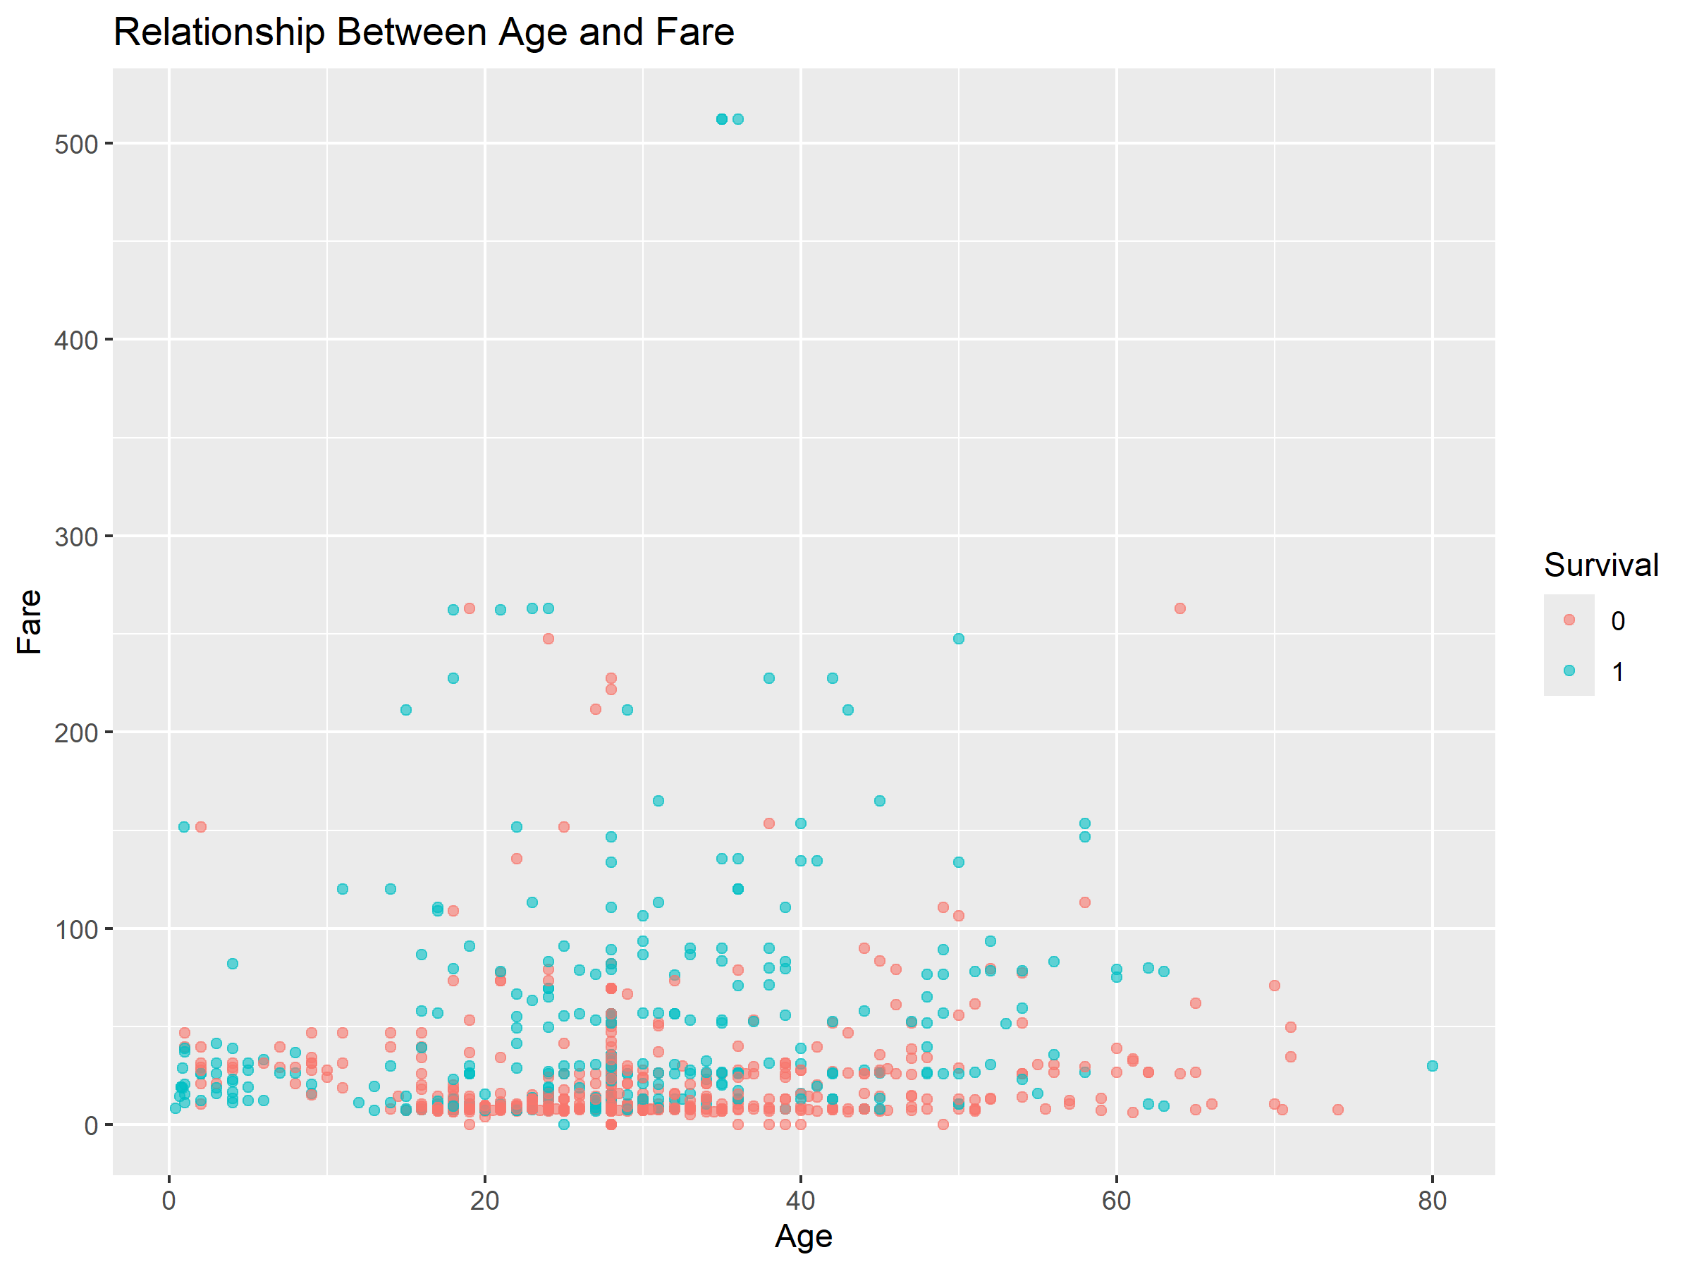

5.4 Survival Rate by Passenger Class
A line chart was used to display the average survival outcome by passenger class. Because Survived is coded as 0 and 1, the mean within each class represents its survival proportion.
survival_rate <- aggregate(Survived ~ Pclass,
data = data,
FUN = mean)
ggplot(survival_rate,
aes(x = Pclass, y = Survived)) +
geom_line(group = 1) +
geom_point() +
labs(title = "Survival Rate by Passenger Class",
x = "Passenger Class",
y = "Survival Rate")

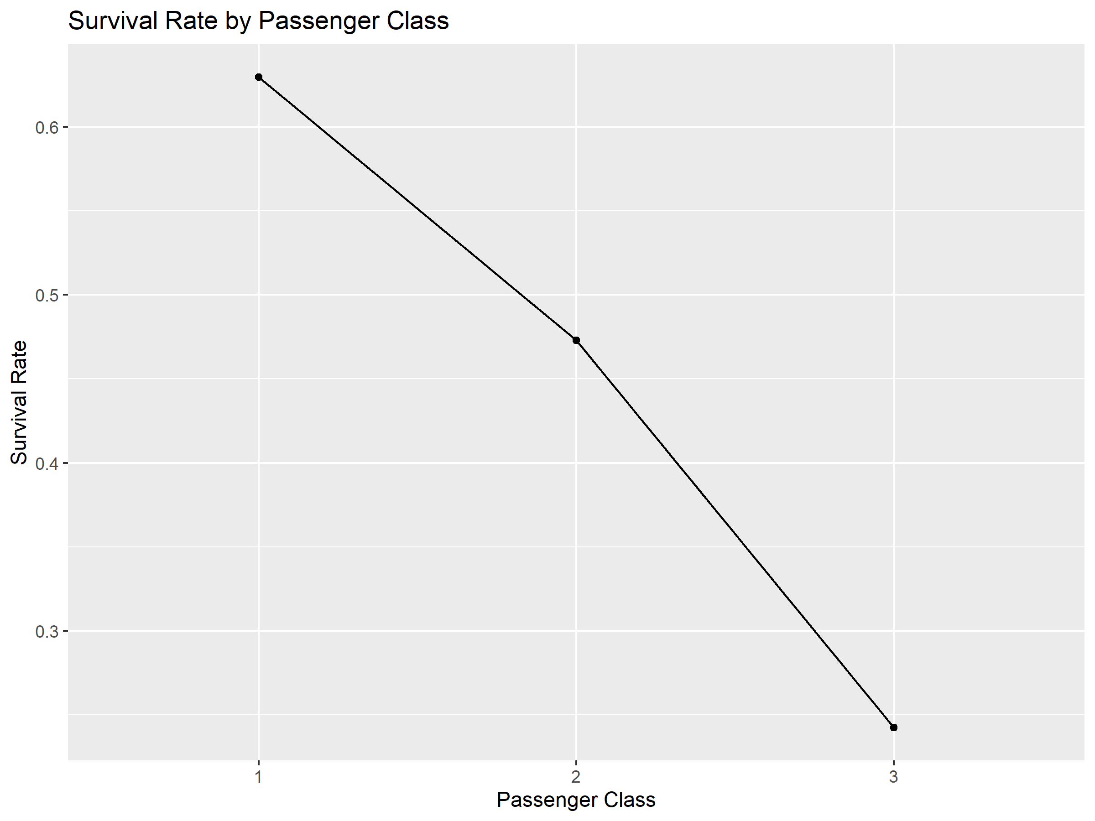

6. Statistical Analysis

6.1 Descriptive Statistics
Mean, median, and standard deviation were calculated for Age and Fare, while frequency tables were used for survival status, passenger class, and sex.
mean(data$Age); median(data$Age); sd(data$Age)
mean(data$Fare); median(data$Fare); sd(data$Fare)
table(data$Survived); table(data$Pclass); table(data$Sex)

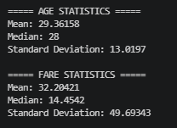
6.1.1 Descriptive Statistics Output:

6.2 Correlation Analysis
Correlation analysis was performed for Age, SibSp, Parch, and Fare to assess the strength and direction of linear relationships among numerical variables.
numeric_data <- data[c("Age", "SibSp", "Parch", "Fare")]
correlation_matrix <- cor(numeric_data, use = "complete.obs")
print(correlation_matrix)

6.2.1 Correction Analysis Output:
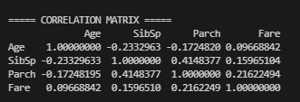

6.3 Hypothesis Testing
A Chi-square test of independence was used to examine the relationship between passenger class and survival.
H₀: Passenger class and survival status are independent.
H₁: Passenger class and survival status are associated.
survival_class_table <- table(data$Pclass, data$Survived)
chi_test <- chisq.test(survival_class_table)
print(chi_test)

6.3.1 Hypothesis Testing Output:
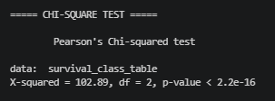

The observed test result was X-squared = 102.89 with 2 degrees of freedom and a p-value below 2.2e-16. At the 0.05 significance level, the null hypothesis is rejected, providing strong evidence of an association between passenger class and survival status.

7. Predictive Modeling

7.1 Logistic Regression
Logistic regression was selected because Survived is a binary outcome. Passenger class, sex, age, and fare were used as predictors.
logistic_model <- glm(
Survived ~ Pclass + Sex + Age + Fare,
data = data,
family = binomial
)
summary(logistic_model)

7.1.1 Logistic Regression Output:
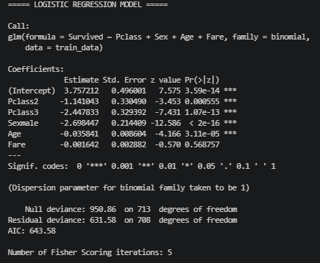

The fitted model indicates that passenger class, sex, and age provide important information for survival prediction, while Fare is less statistically prominent in the fitted model.

7.2 Train-Test Split
The dataset was divided into training and testing subsets using an 80:20 split. The training set contained 714 observations and the testing set contained 177 observations.
set.seed(123)
train_index <- createDataPartition(data$Survived, p = 0.80, list = FALSE)
train_data <- data[train_index, ]
test_data <- data[-train_index, ]
nrow(train_data); nrow(test_data)

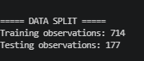
7.2.1 Train-Test Split Output:

7.3 Five-Fold Cross-Validation:
Five-fold cross-validation was applied to the training data to obtain a more robust estimate of model performance. Each subset was used once as validation data while the remaining subsets were used for training.
set.seed(123)
cv_control <- trainControl(method = "cv", number = 5, classProbs = TRUE)
cv_model <- train(
Survived ~ Pclass + Sex + Age + Fare,
data = train_data,
method = "glm",
family = binomial,
trControl = cv_control
)
print(cv_model)

7.3.1 Five-Fold Cross-Validation Output:
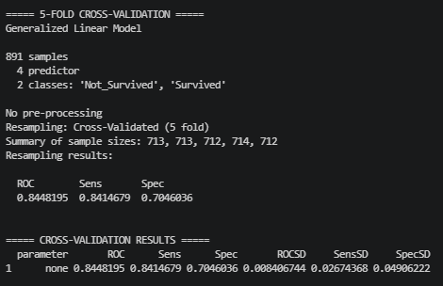

7.4 Model Training and Prediction:
The logistic regression model was trained on the training dataset and generated survival probabilities and predicted classes for the test dataset.
train_model <- glm(
Survived ~ Pclass + Sex + Age + Fare,
data = train_data,
family = binomial
)
predicted_prob <- predict(train_model, newdata = test_data, type = "response")
predicted_class <- ifelse(predicted_prob >= 0.5, "1", "0")
predicted_class <- factor(predicted_class, levels = levels(test_data$Survived))

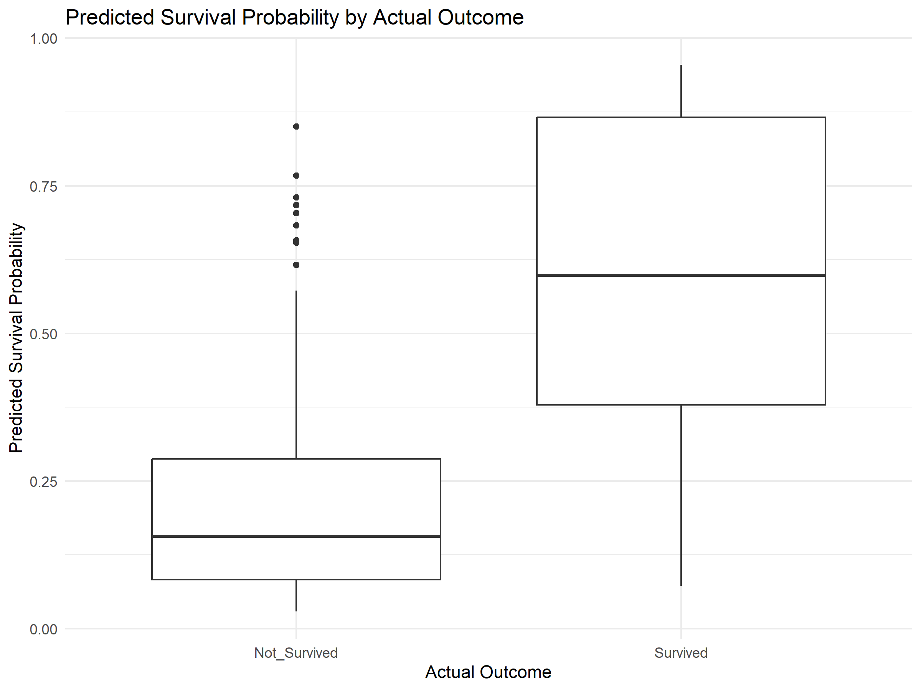
7.4.1 Model Training and Prediction Output:

8. Model Evaluation

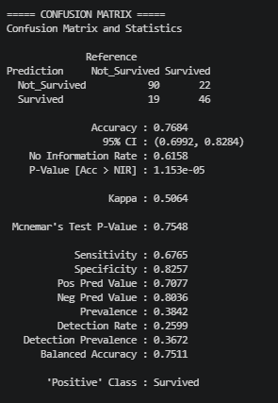
8.1 Confusion Matrix and Classification Metrics
The confusion matrix compares predicted survival classes with actual classes in the test dataset. Accuracy, sensitivity, and specificity were used to evaluate classification performance.
confusion_matrix <- confusionMatrix(
predicted_class, test_data$Survived, positive = "1"
)
print(confusion_matrix)
confusion_matrix$overall["Accuracy"]
confusion_matrix$byClass["Sensitivity"]
confusion_matrix$byClass["Specificity"]

8.2 ROC Curve and AUC
The ROC curve evaluates the model's ability to distinguish between surviving and non-surviving passengers across classification thresholds. AUC summarizes the model's discrimination ability.
roc_curve <- roc(test_data$Survived, predicted_prob,
levels = c("0", "1"), direction = "<")
auc_value <- auc(roc_curve)
print(auc_value)
plot(roc_curve, main = "ROC Curve - Logistic Regression")

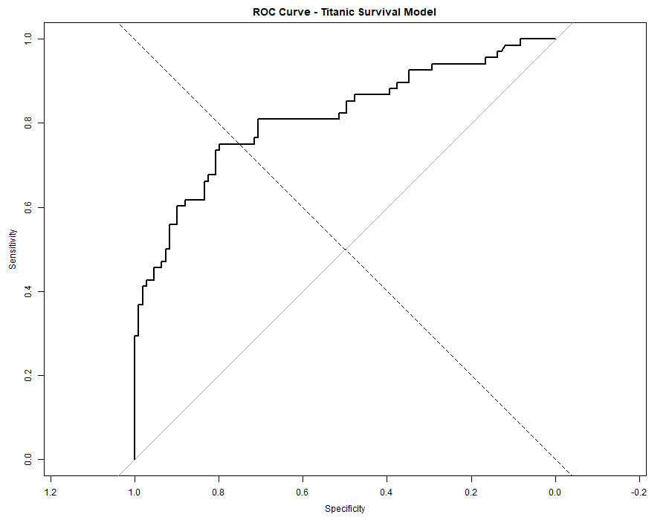

9. Diagnostic Analysis

9.1 Cook's Distance
Cook's Distance was used to identify observations that may have a relatively strong influence on the fitted logistic regression model. Observations with comparatively larger values can be investigated further for potential influence on model estimates.

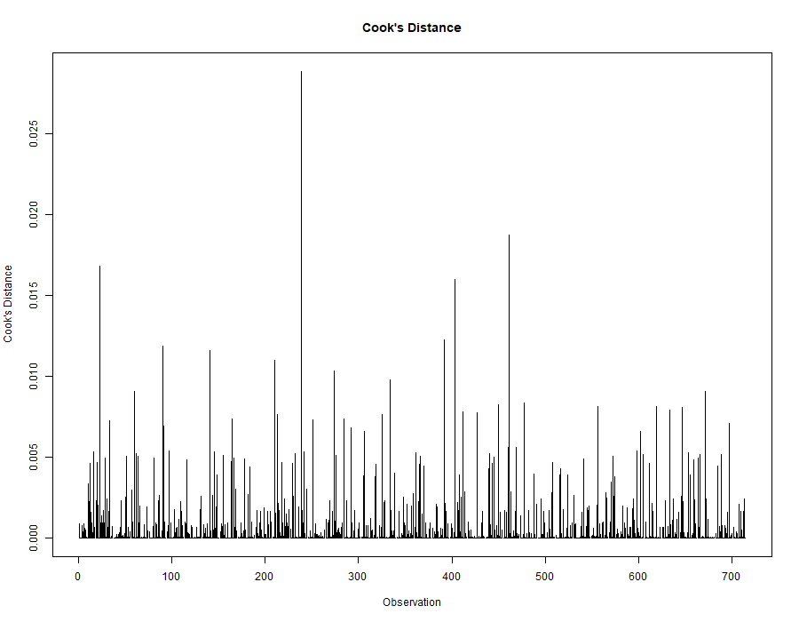

Figure: Cook's Distance diagnostic plot for the logistic regression model.

10. Integrated Results and Key Insights
- Survival outcomes differed noticeably across passenger classes.
- Passenger age showed a broad distribution with greater concentration in particular age ranges.
- Fare values varied substantially, and Age and Fare did not show a simple strong linear relationship.
- The Chi-square test provided strong statistical evidence of an association between passenger class and survival.
- Logistic regression provided a classification framework using passenger class, sex, age, and fare.
- The model was evaluated using an independent test set, five-fold cross-validation, classification metrics, and ROC/AUC analysis.
- Cook's Distance provided an additional diagnostic view of potentially influential observations.

11. Discussion and Practical Implications
The combined analysis demonstrates the value of using multiple analytical methods rather than relying on a single visual or statistical result. Exploratory visualizations identify patterns that can then be examined formally through statistical testing. The strong association between passenger class and survival suggests that passenger class is an important factor when interpreting survival outcomes in this dataset.
From a practical data-analysis perspective, the project demonstrates how descriptive analysis, visualization, hypothesis testing, and predictive modeling can complement one another. The predictive model provides classification insight, but its results should be interpreted within the limitations of the available variables and historical dataset.

12. Challenges Encountered
- Handling missing values while maintaining the analytical usefulness of the dataset.
- Converting categorical variables into appropriate factor representations for statistical modeling.
- Selecting visualization types that match the structure and purpose of each analytical question.
- Interpreting statistical test results without confusing statistical association with causation.
- Building and evaluating a classification model while checking predictive performance and diagnostics.
- Resolving R package and execution issues during the modeling workflow.

13. Recommendations and Future Directions
- Compare logistic regression with alternative classification algorithms such as decision trees or random forests.
- Investigate interaction effects among important predictors.
- Perform additional feature engineering where justified.
- Use repeated or stratified cross-validation for more robust performance estimates.
- Examine additional evaluation metrics when class imbalance or different error costs are important.
- Investigate influential observations identified by diagnostic analysis.
- Consider broader datasets and additional explanatory variables for future predictive studies.

14. Conclusion
This comprehensive analysis applied an end-to-end R workflow covering data preparation, visualization, statistical analysis, hypothesis testing, predictive modeling, model evaluation, and diagnostic assessment. The exploratory analysis highlighted important differences in survival outcomes across passenger classes and variation in passenger age and fare.
The Chi-square test provided strong evidence of an association between passenger class and survival status. A logistic regression model was developed to predict survival using passenger class, sex, age, and fare. The model was assessed using an 80:20 train-test split, five-fold cross-validation, a confusion matrix, classification metrics, ROC/AUC analysis, and Cook's Distance.
Overall, the project demonstrates how a structured data-driven approach can combine exploratory and statistical methods with predictive modeling to produce interpretable findings. Future improvements could include comparing alternative models, testing additional predictors and interactions, and applying more extensive validation techniques.

